# Technical Architecture:

Project Design Phase-II Technology Stack (Architecture & Stack)

|  |  |
| --- | --- |
| Date | 15 October 2022 |
| Team ID | PNT2022TMID34828 |
| Project Name | Project – Skill/Job Recommender Application |
| Maximum Marks | 4 Marks |

Guidelines:

1. Include all the processes (As an application logic / Technology Block)
2. Provide infrastructural demarcation (Local / Cloud)
3. Indicate external interfaces (third party API’s etc.)
4. Indicate Data Storage components / services
5. Indicate interface to machine learning models (if applicable)

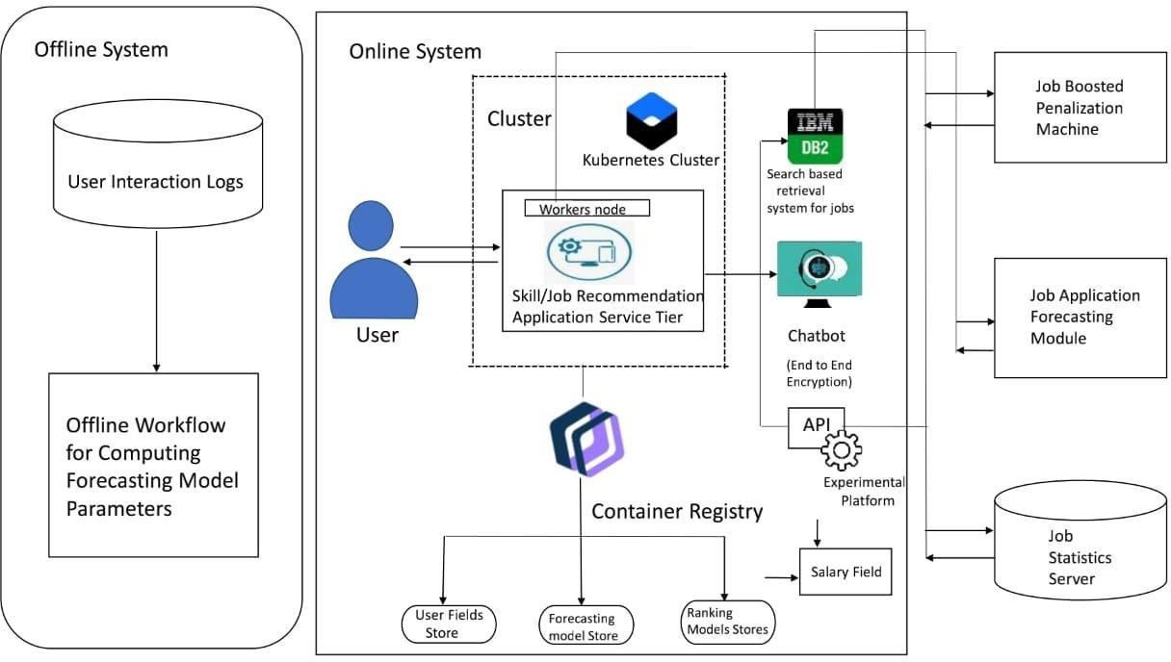

# Table-1 : Components & Technologies:

|  |  |  |  |
| --- | --- | --- | --- |
| **S.No** | **Component** | **Description** | **Technology** |
| 1. | User Interface | How user interacts with application e.g. Web UI, Mobile App, Chatbot etc. | HTML, CSS, JavaScript / Angular Js / React Js etc. |
| 2. | Developing Interface | Developing application for the task | Java / Python |
| 3. | Voice Assistance | Voice commands instead of typing. | IBM Watson STT service |
| 4. | Chatbot Assistance | Conversational Interface | IBM Watson Assistant |
| 5. | Database | Data Type, Configurations etc. | MySQL, NoSQL, etc. |
| 6. | Cloud Database | Database Service on Cloud | IBM DB2, IBM Cloudant etc. |
| 7. | File Storage | File storage requirements | IBM Block Storage or Other Storage Service or Local Filesystem |
| 8. | Machine Learning Model | Purpose of Machine Learning Model | Object Recognition Model, etc. |
| 9. | Infrastructure (Server / Cloud) | Application Deployment on Local System / Cloud Local Server Configuration:  Cloud Server Configuration : | Local, Cloud Foundry, Kubernetes, etc. |

**Table-2: Application Characteristics:**

|  |  |  |  |
| --- | --- | --- | --- |
| **S.No** | **Characteristics** | **Description** | **Technology** |
| 1. | Open-Source Frameworks | List the open-source frameworks used | Technology of Opensource framework |
| 2. | Security Implementations | List all the security / access controls implemented, use of firewalls etc. | e.g. SHA-256, Encryptions, IAM Controls, OWASP etc. |
| 3. | Scalable Architecture | Justify the scalability of architecture (3 – tier, Micro- services) | Artificial Intelligence (AI) |
| 4. | Availability | Justify the availability of application (e.g. use of load  balancers, distributed servers etc.) | RAID(redundant array of independent  disks) |

|  |  |  |  |
| --- | --- | --- | --- |
| **S.No** | **Characteristics** | **Description** | **Technology** |
| 5. | Performance | Design consideration for the performance of the application (number of requests per sec, use of  Cache, use of CDN’s) etc. | DRAM or flash memory |